THE CUBAN REVOLUTION

By Dalaney Blottenberger



. Began in 1952 when former army sergeant Fulgencio Batista

seized power

. Batista was president from 1940-1944

. He ran again in 1952

. When he realized he couldn’t win he seized power before

the elections could finish

. Many people infuriated by Batista and his power grab

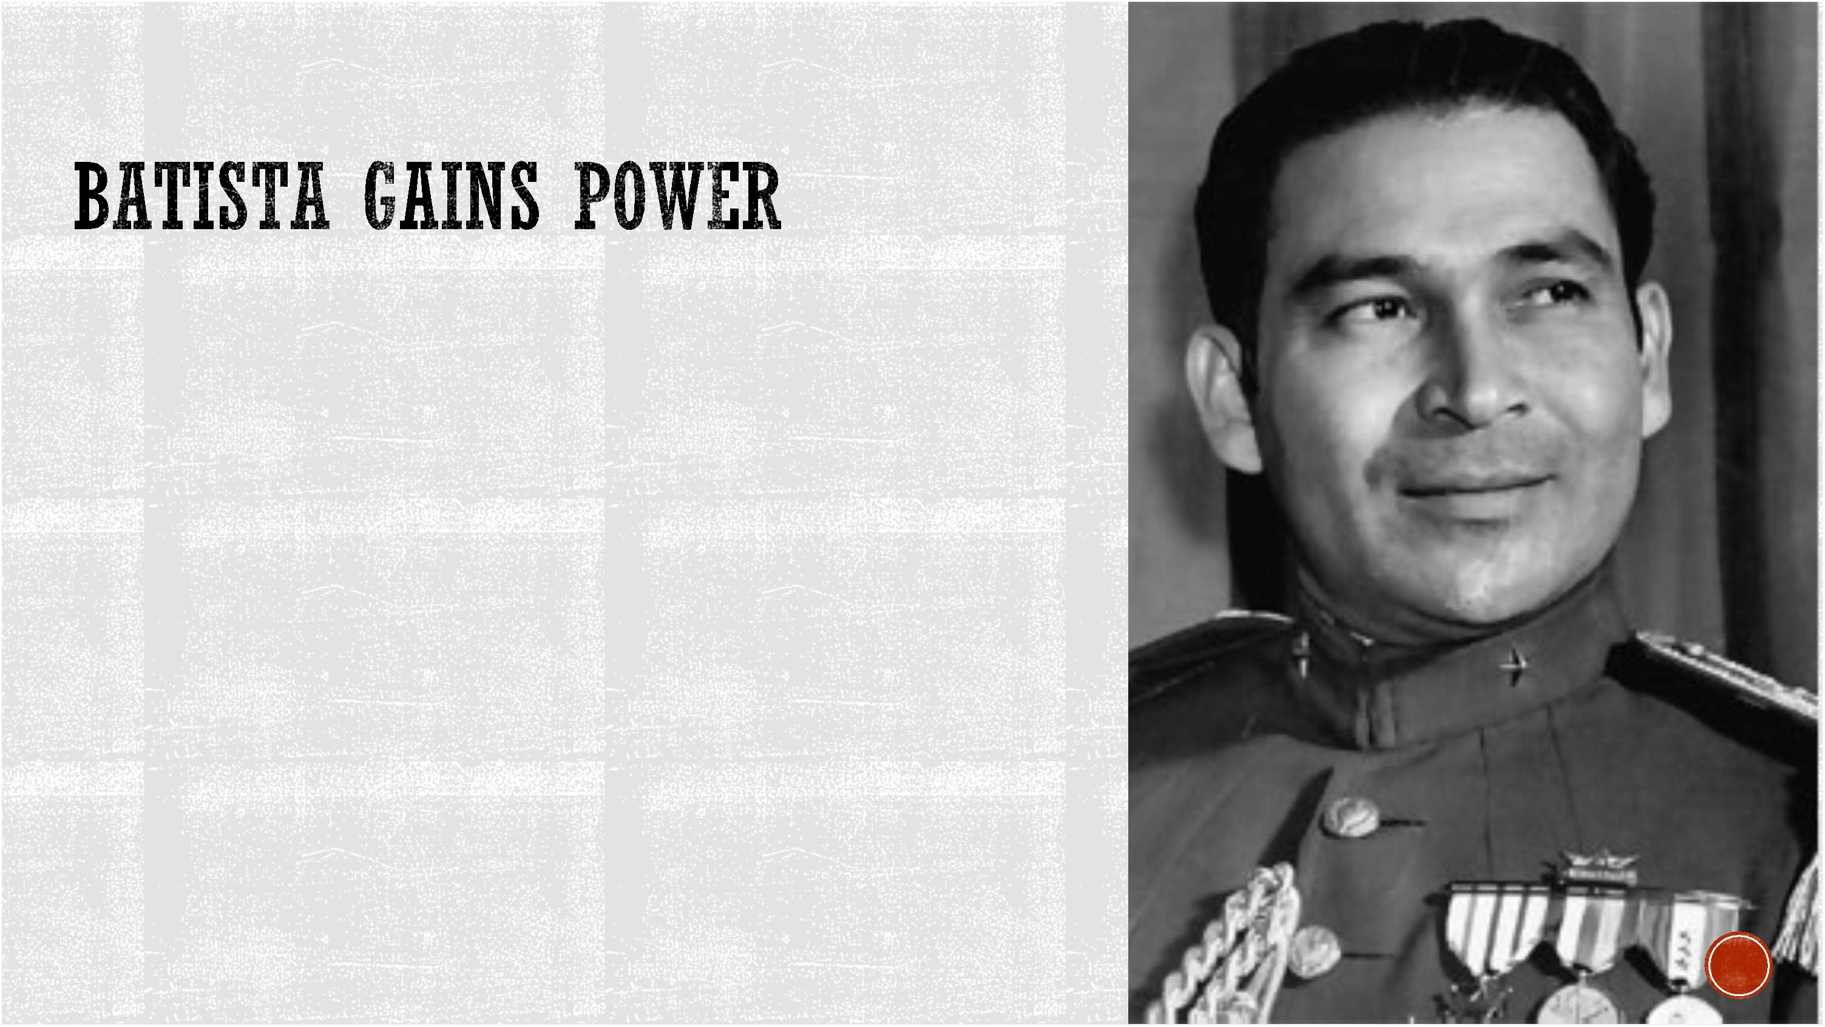

. One particular politician that was extremely vocal about his

disapproval of Batista was Fidel Castro.

. Castro almost immediately began plotting Batista's downfall

. On the morning of July 26, 1953 Castro and 138 other men

attack Moncada.

. The fight was unsuccessful and led to many being captured

or killed.

. Castro escaped but was later caught.

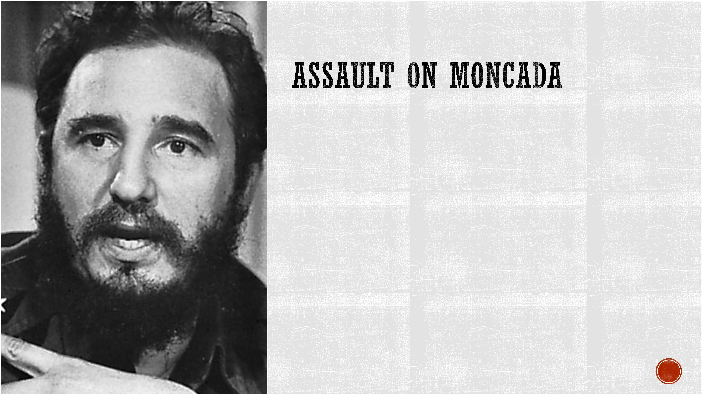

. Castro and the surviving rebels were put on

trial

. Castro was a trained lawyer and managed

to turn the tables on Batista by making the

trial about his dictatorship and power grab

. Castro pled that it was his civil duty as a

loyal Cuban to fight

. Batista's government tried to get him to shut

up by claiming he was too ill to stay on trial

. He was sentenced to fifteen years in prison.

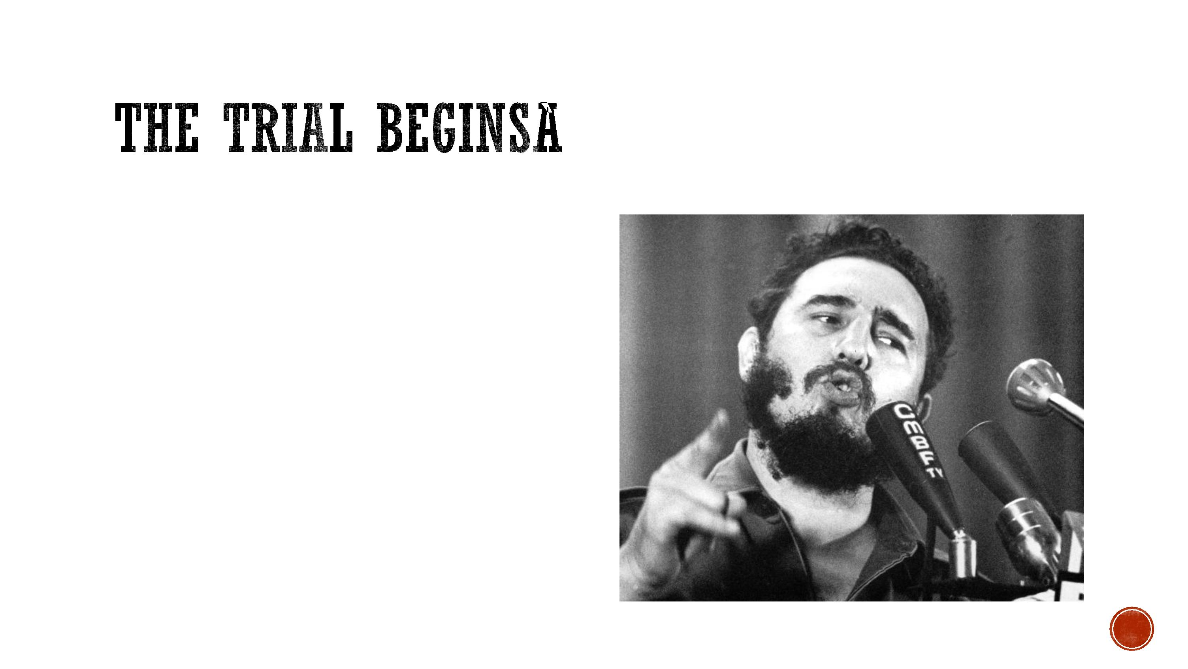

RELEASED

. In May of 1995 Batista's government bent to the urging pressure to reform

. They released many political prisoners including those who took place in the

Moncada Attack

. Fidel left for Mexico in hopes of regrouping and restarting the revolution

. There he gained movement by adding new rebels to his group



HIGHLANDS

. Batista's men had heard of the new threat and ambushed them forcing Castro into

the highlands

. In the highlands the rebels regroup adding more members and more weapons

. As the movement gained power more rebels were added

. Batista decided to send an army into the highlands

. They were brutally beaten by the growing rebels

. By the end of 1958 Castro was ready to make his move



. In late 1958 Castro dived his forces

and made his way into towns

. He was greeted with excitement

. Batista and his inner circle saw that

Castro's win was inevitable and ran

for the hills

. Castro had won.

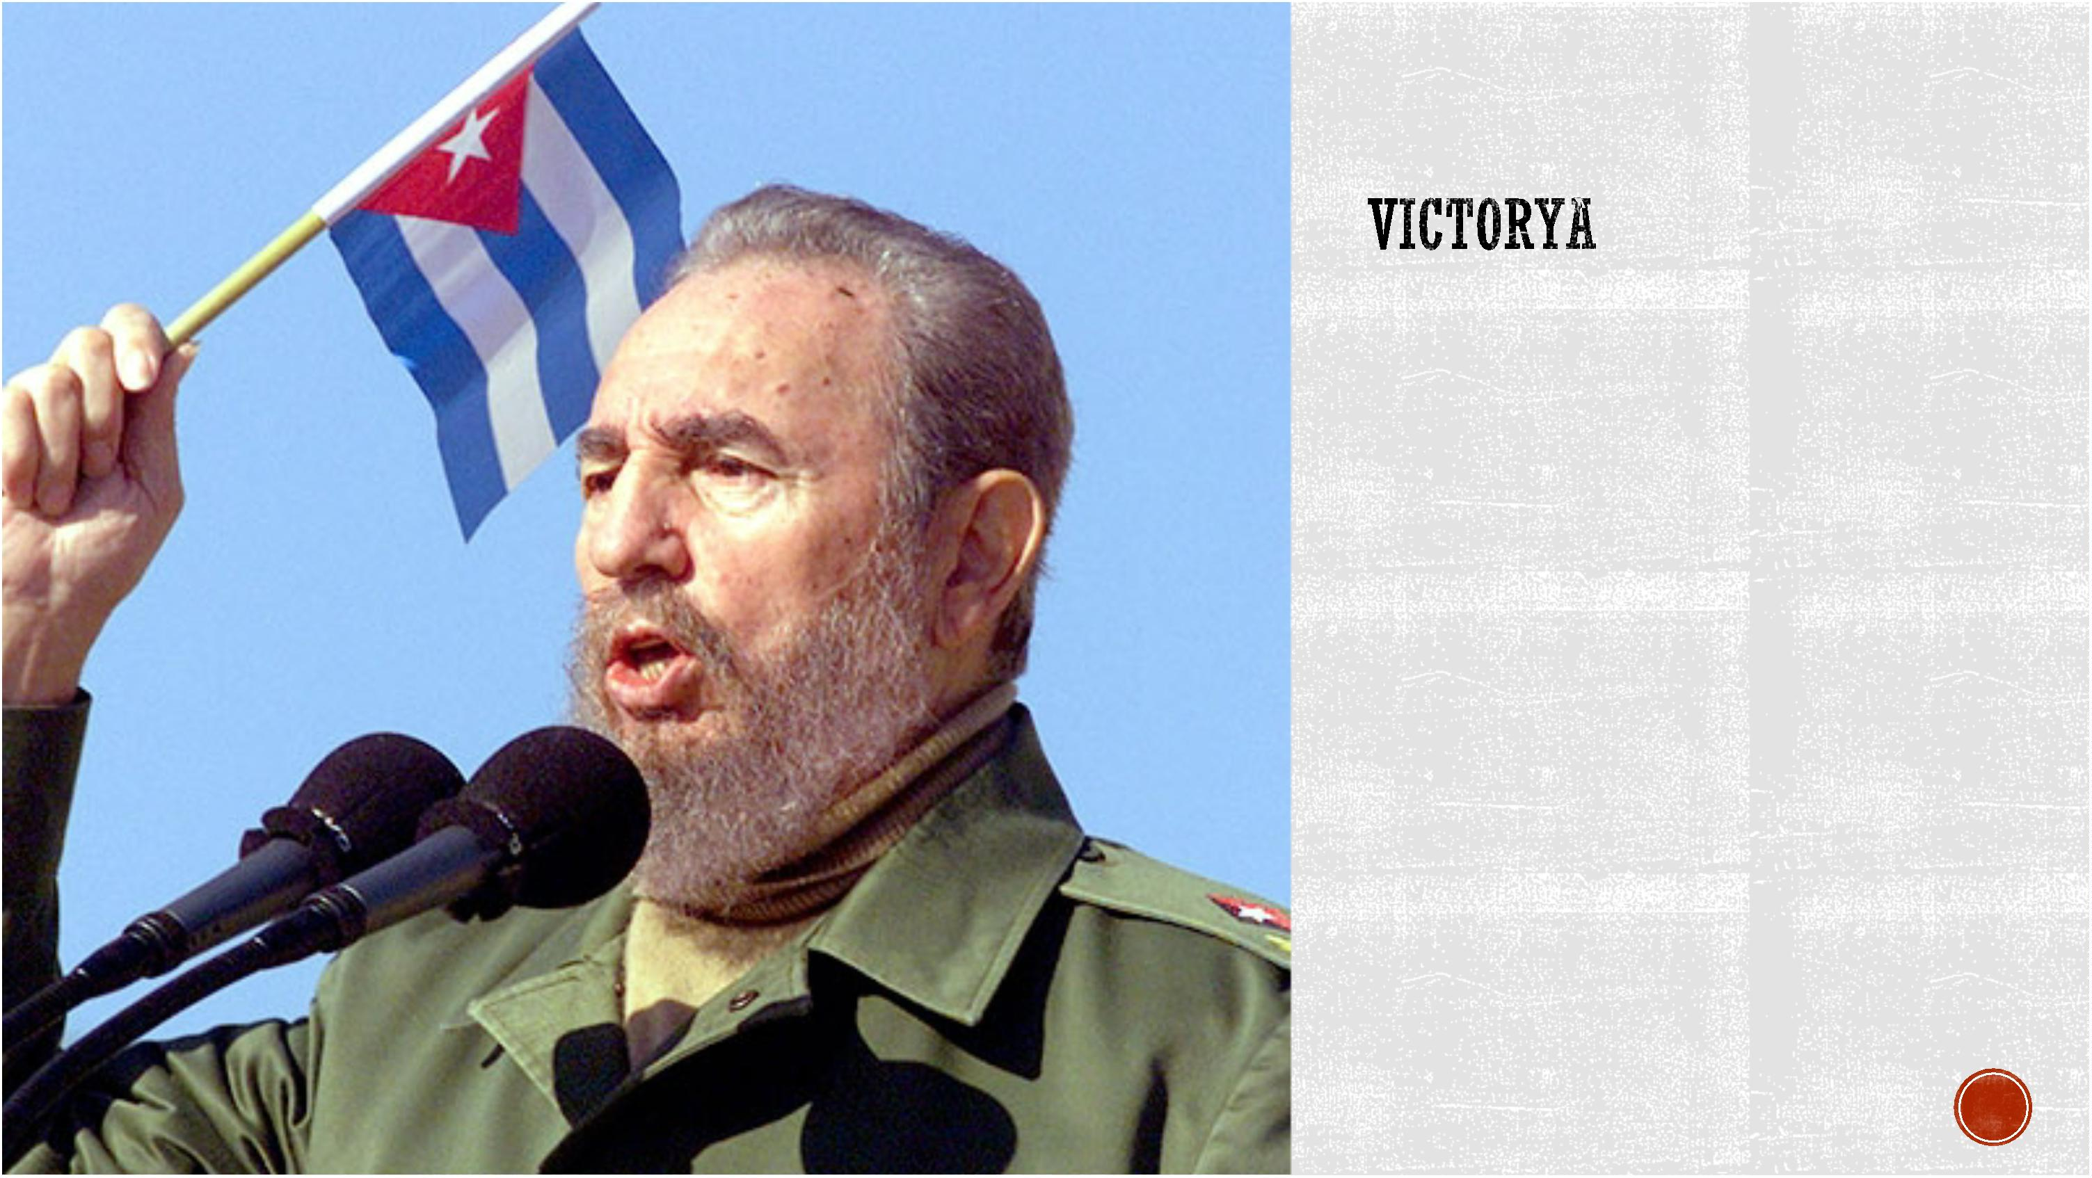

. https://www.washingtonpost.com/world/fidel-castro-cuban-dictator-dies-at-

90/2016/11/26/f37bf3bc-b399-11e6-be1c-

8cec35b1ad25_story.html?utm_term=.47b1ce24db93

. https://www.biography.com/people/fidel-castro-9241487

